Final report of the Frizzly Fitness App

Table of contents

1. Features/ future features
2. Known issues
3. Flyer
4. Current members
5. Abstract
6. Testing
7. Documentation
8. Usability notes
9. Installation and user documentation
10. Use license and ip agreements
11. Sprint charts

1.

The current feature in the app so are as follows

* Create and name trails attitudes
* Two different login methods (0ne internally made, the other with google logins)
* Working google map
* A page that shows past trails that have been saved, and/or completed
* A semi working blog
* Low security Authentication (needs to be improved)
* Working timer

Future features to add

* User being able to create their own checkpoints
* Have the blog section be able to be commented by other users and be able to leave reviews
* Offline gps tracking (see if its possible first)
* Create a content page for the trails
* qr codes that hold information about the GGC created trails

2.

Current issues

* some of the dependences needed to run are currently depreciated
* format on mobile devices work just a little off aesthetically
* there is an input overflow error when over 256 characters are entered to a text box

3.

Current flyer

* 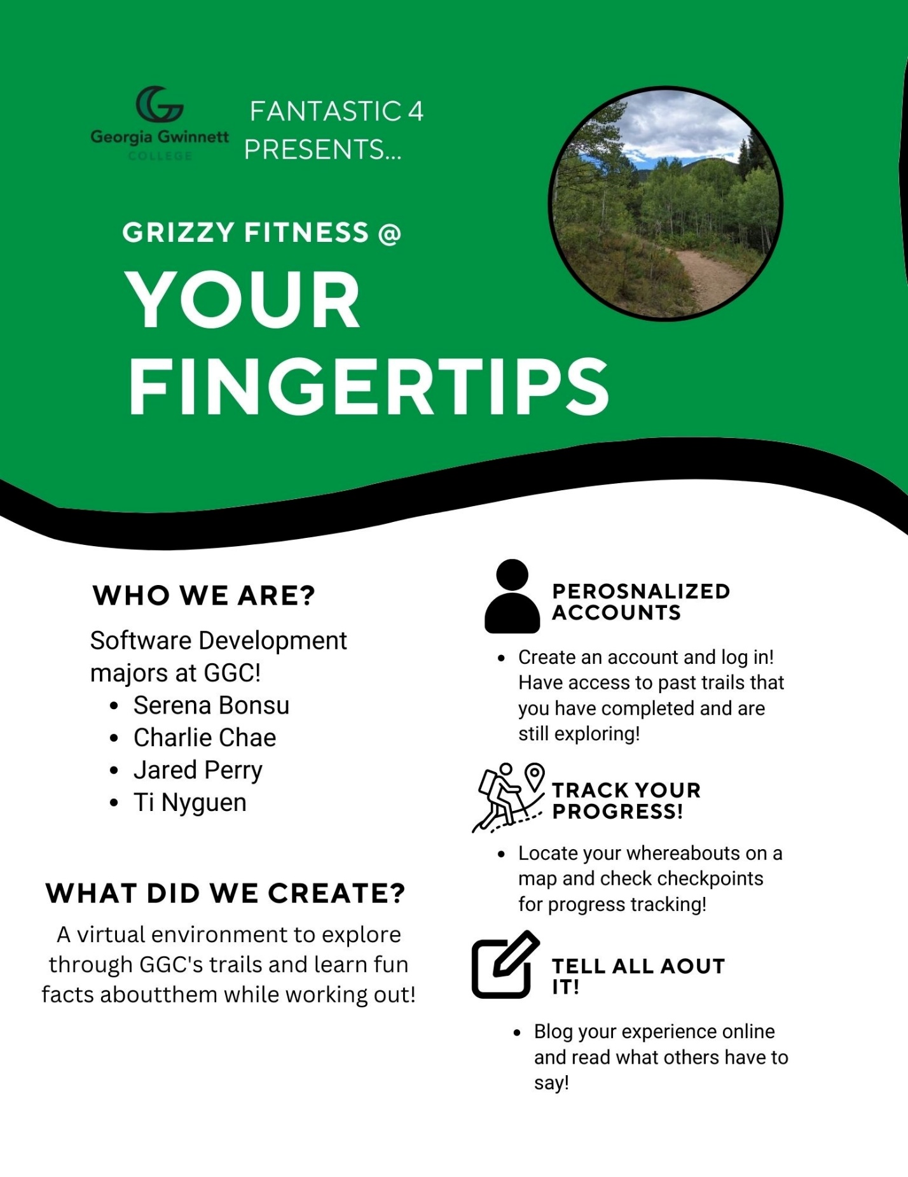

4.

Link to the youtube video of a Short demo of the app in use

* https://youtu.be/j3sLqDTzJUw

Current 2022 fall members

5.

* 
* The clients Karen perell-Gerson, and Kristie Waisdorf are professor at GGC in the Exercise Science, there looking to create an app that will be used for the health, and exercise course, but hope to expand the app out to all Gwinnett.
* 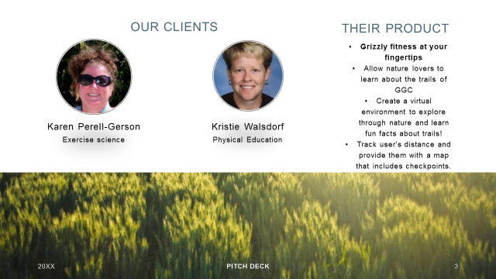

6.

Abstract

What is This?

We are team fantastic 4 and we are here to present our project GGC Trail Walking Application

The Purpose of the Application.

GGC Trail Walking App this application will show you various trails along GGC along with fun facts that can be scan from QR codes that will be placed along the trails. When the qr codes are scanned they will provide you with exercise advice and other fun facts around for the area.

This application was originally designed for students and faculty in the PHED 1080 or Fitness for Life Walking class here at GGC. This was meant to help keep track of the speed each student was able to complete the trail within the time period set by the class. The app would aid the professors make decisions about the pace the class was able to complete the various trails.

7.

Testing

* Testing was done with the testing program called “Jest”
* Snapshot testing was used to identity overflow errors
* Results aside from the overflow error is that the program does work in its current form as intended.

8.

Documentation

* The read me will contain the guide for the following
  + Installation
  + Use guide
* Help pages will be in the doc-2022 folder on the git hub repository
* Code documentation should be within the code files themselves

9.

Usability

* The background images needed to be changed to fit GGC more
* The blog pages need to be more interconnected with the rest of the app
* Adjust the format for mobile device which will be the primary user of the app

10.

Installation

* All installation steps will be within the readme document
* Developer and user guides will be within the doc-2022 floder

11.

IP and software license

* IP license will be in the doc-2022 folder in git hub
* Software usage will be in the doc-2022 folder in git hub

12.

Sprint 1

* Velocity
  + 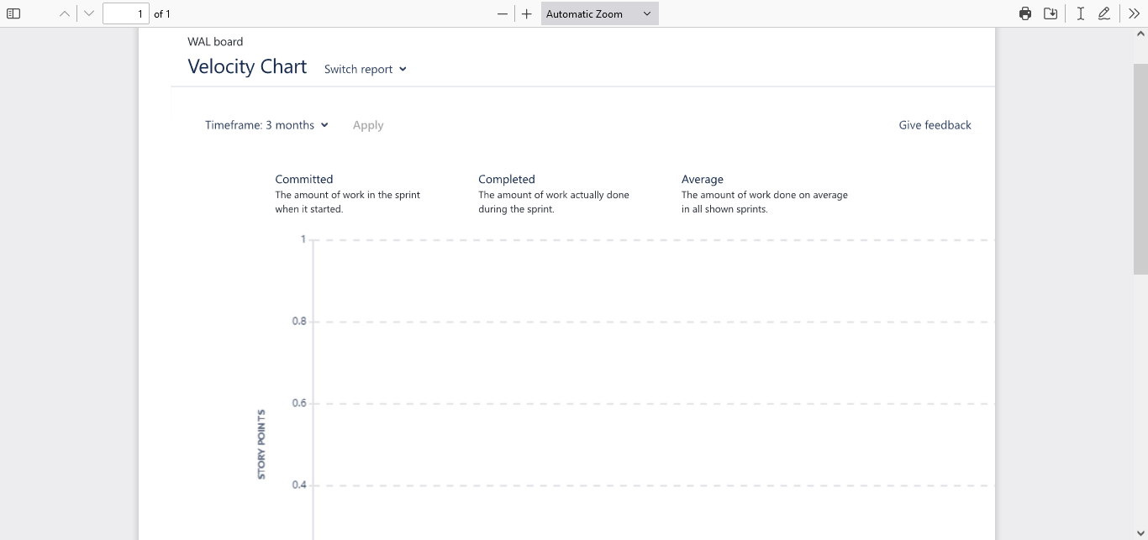
* Burndown
  + 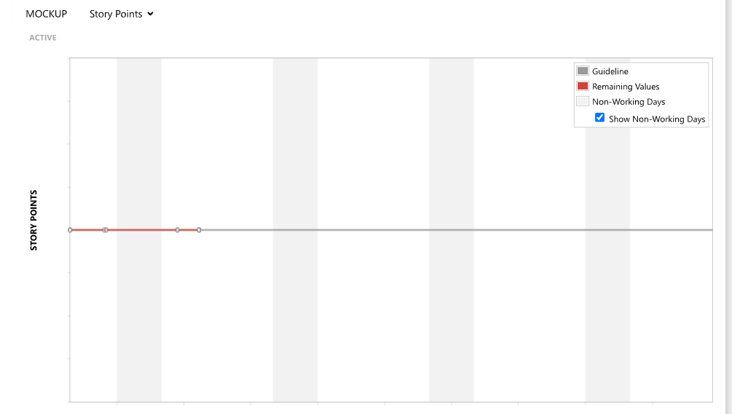

Sprint 2

* Velocity
  + 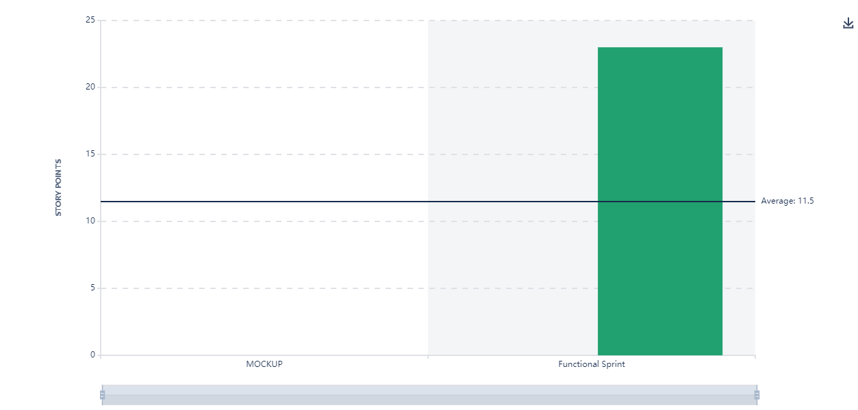
* Burndown
  + 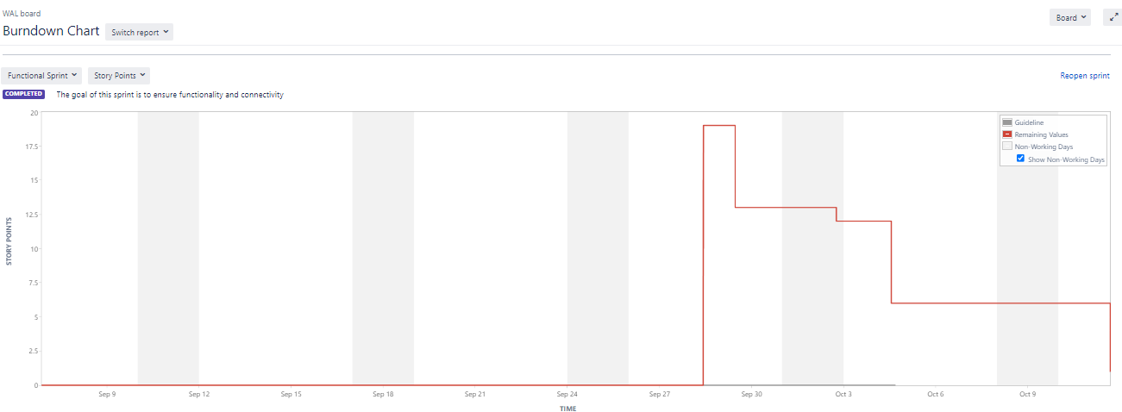

Sprint 3 The burn down chart

* 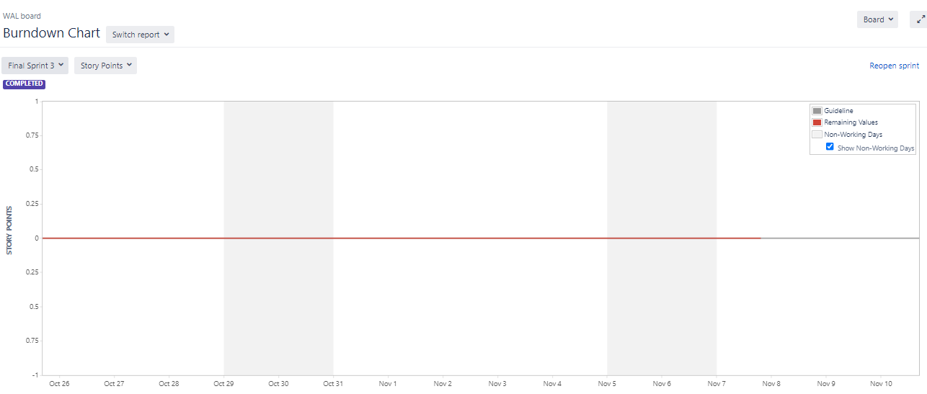
* Velocity chart
  + 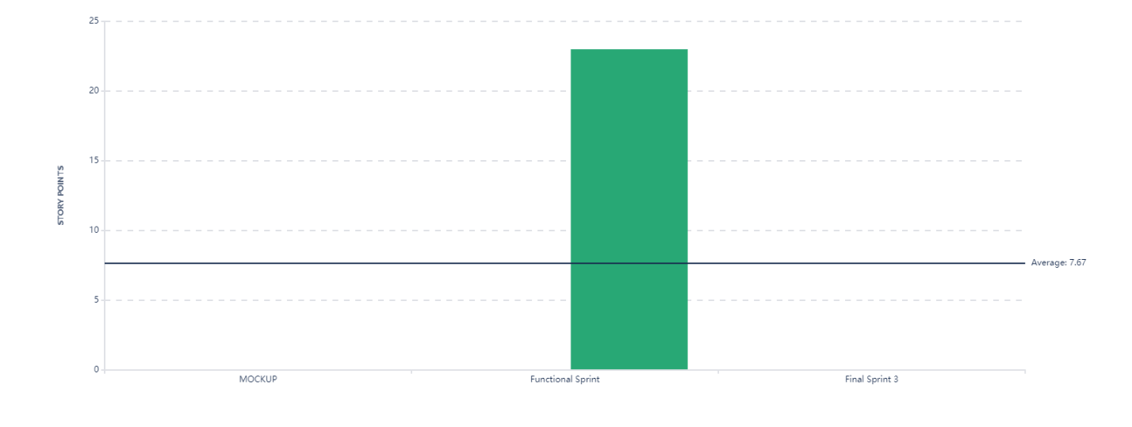
* The bad there were not many task we could do in the last sprint that was feasible in the time left in the semester so we just focused on visual aesthetic, google map api, and a timer.

As a team we never remember about jira for most of the semester.

* The good must functionality is there and can be expanded upon in he future